Author: Bo , making it shaking ing.arward to next ch point to make them on of points, by using queue to contain it. in CS3451 PROJECT 1 REPORT

The title: CS3451 Fall 2014, Project1 TRIAL VISUALIZATION

Author: Bo Chen Shen Yang

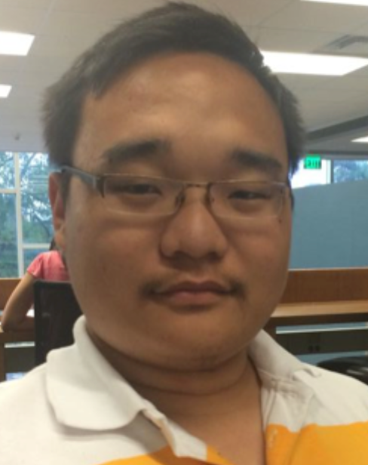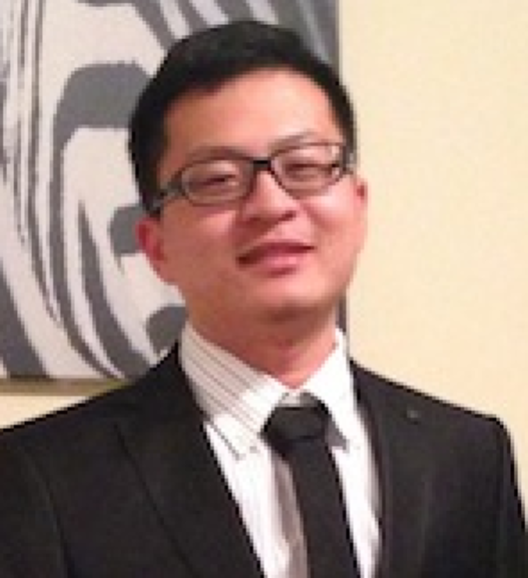

Project 1 TRIAL VISUALIZATION:

Implement different modes of manipulating a blue point by teleporting, when the mouse is pressed.

We have created 3 mode of the movement of circle, from the basic to smooth mode. In the first mode, we just create the basic trail to contains 30 last location of points, by using queue to contain it. In the second mode, we are updating the location of each point to make it move forward to next point’s location by using midpoint of two points.

Here are some code we did in the program:

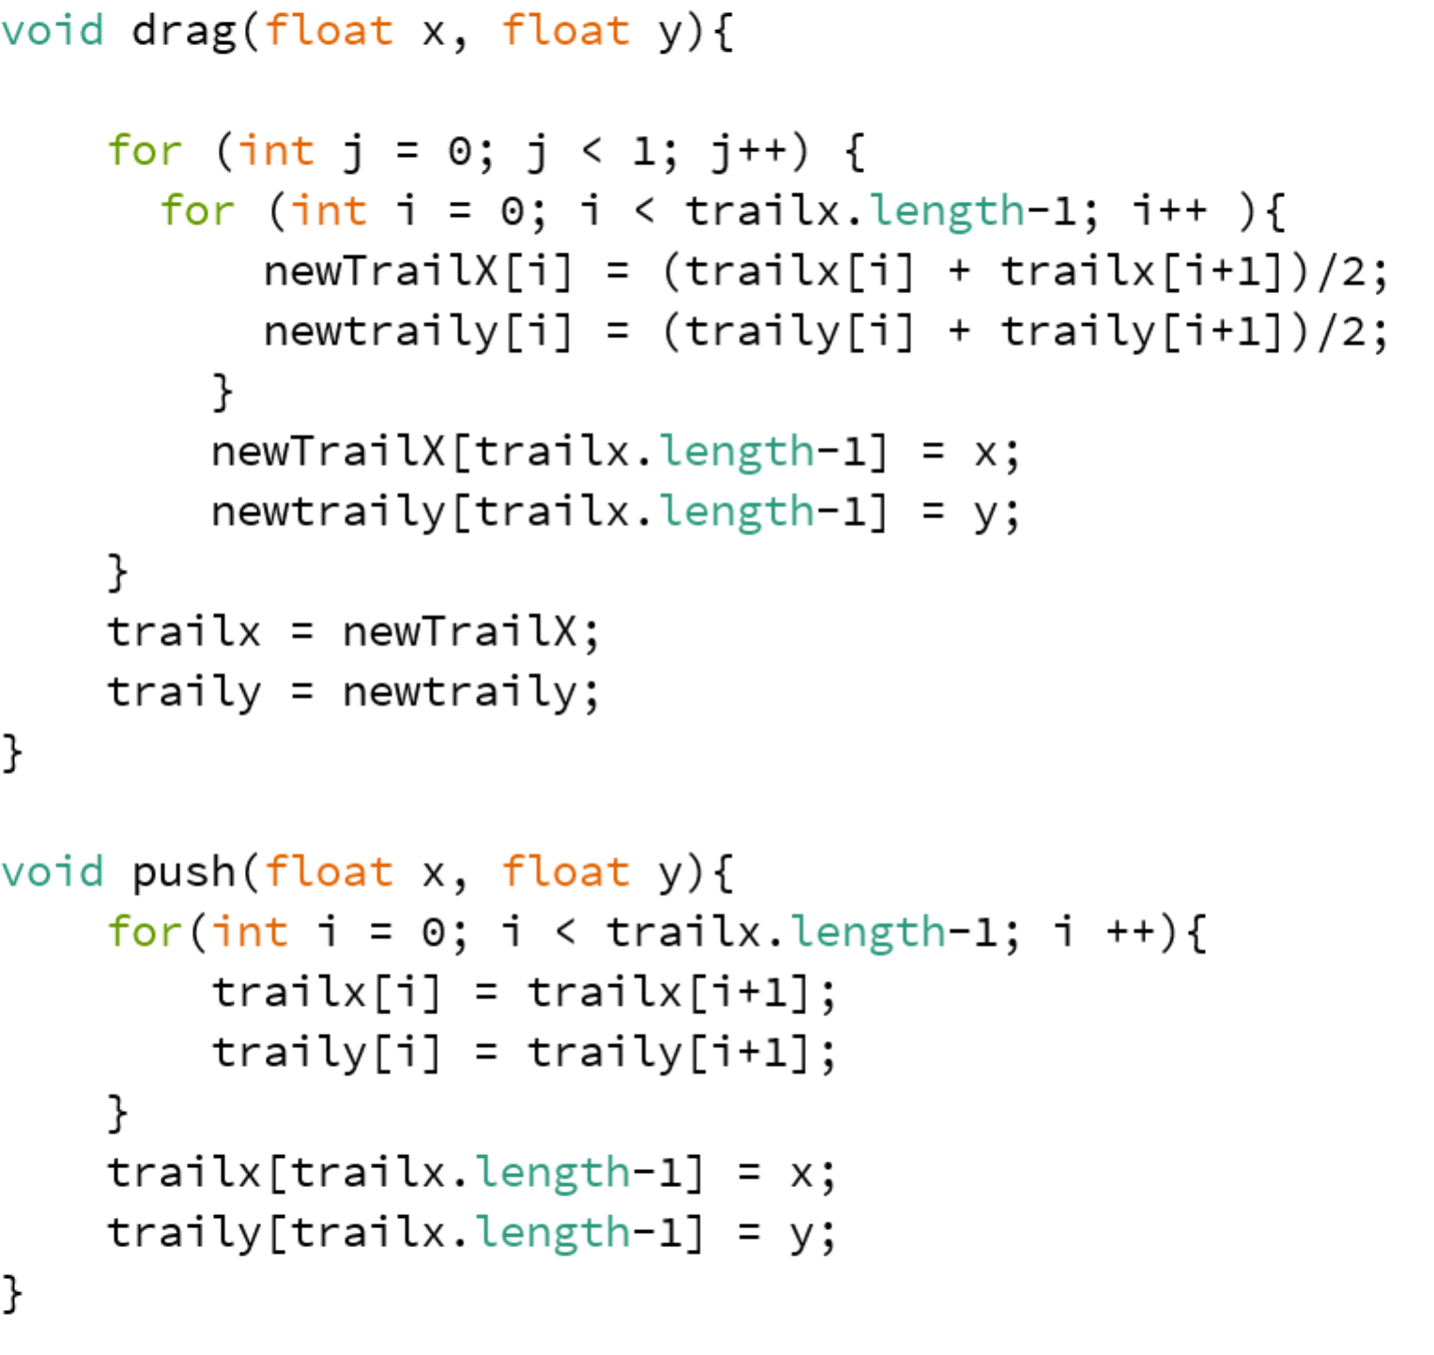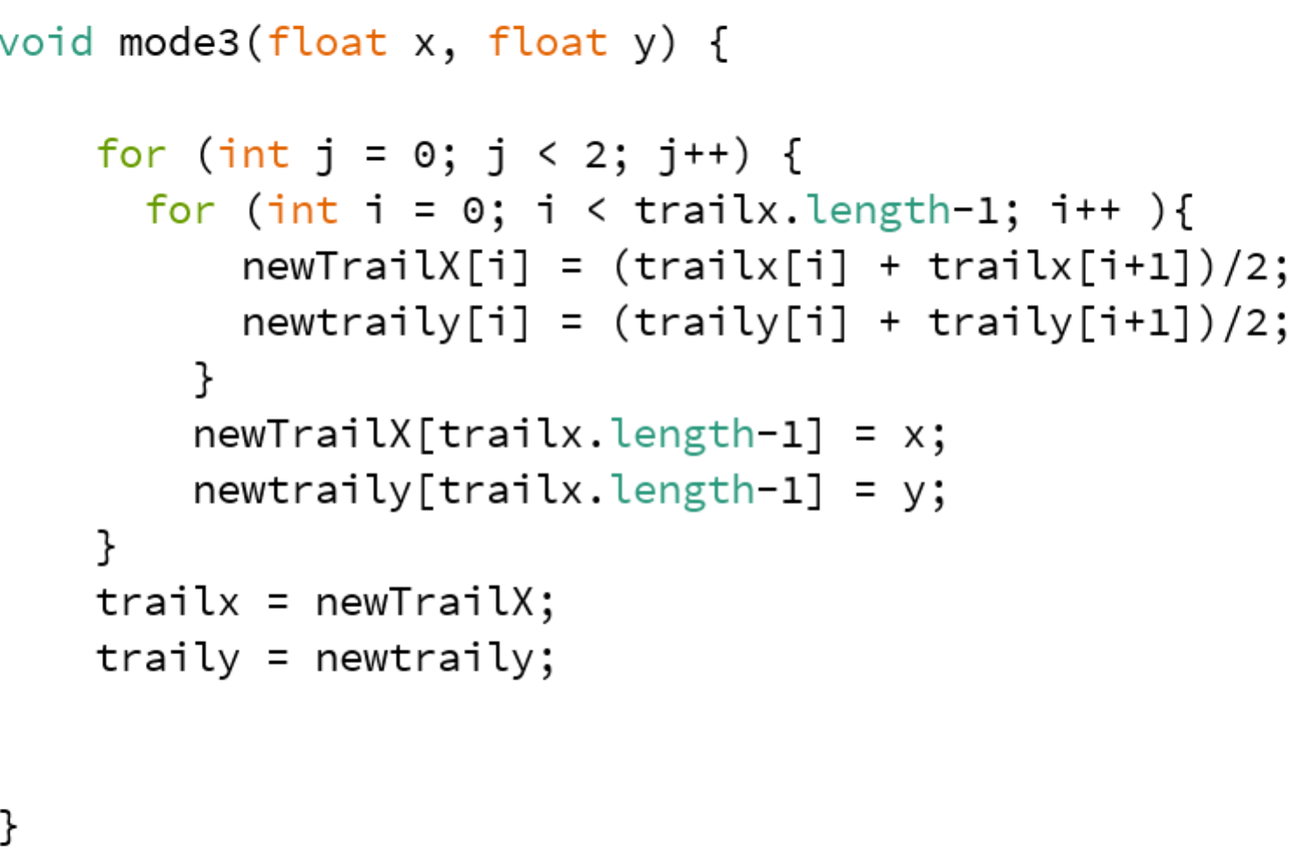

Here is our program works:

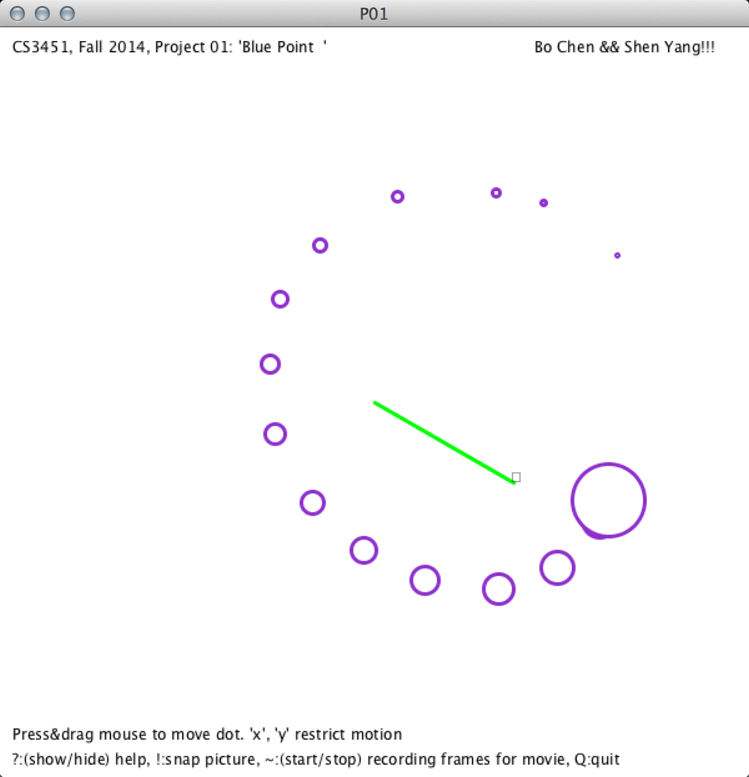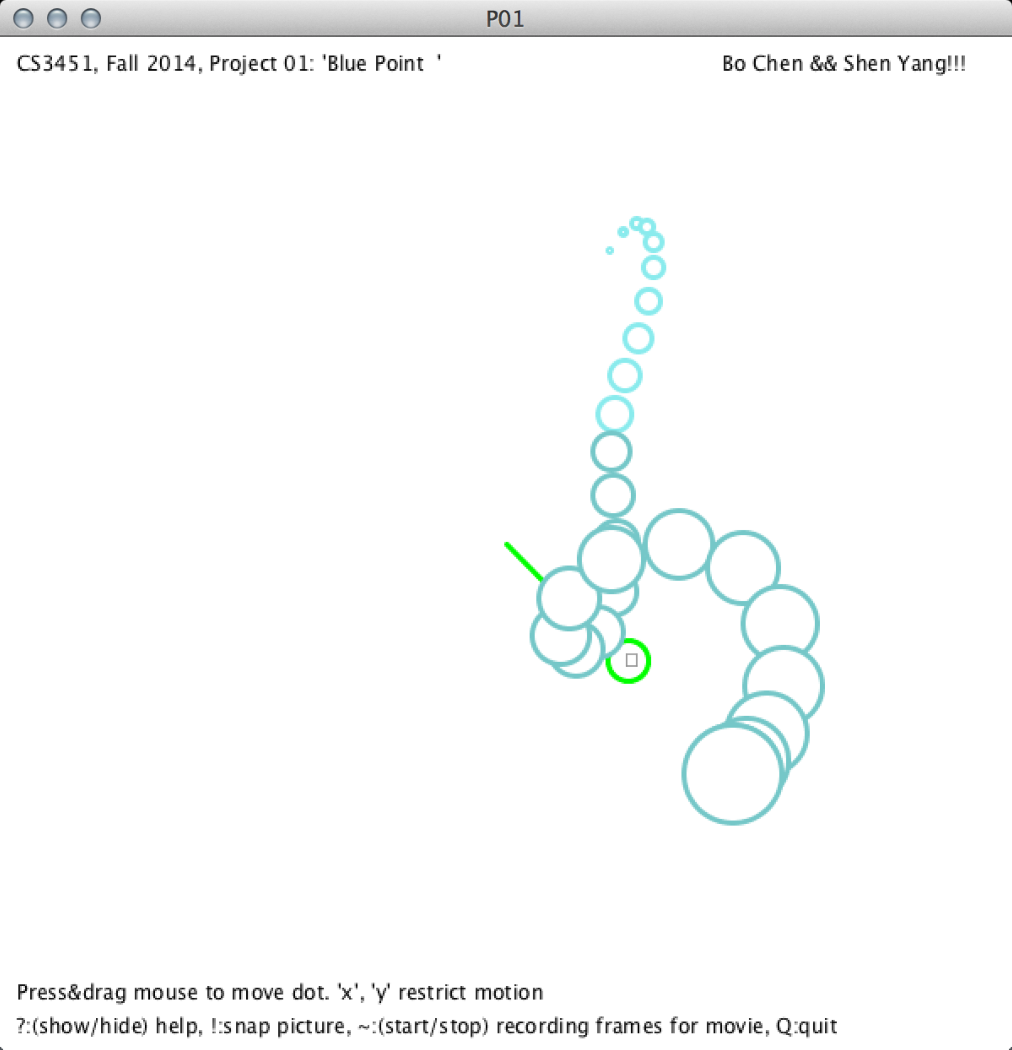

in our mode3, we got the idea from mode2! In the mode2, the circle has been moving too fast toward the next point, so what we do is get the second time average points from the first average point set. Making it more smoother than mode2 and slows the trail’s disappearing time.

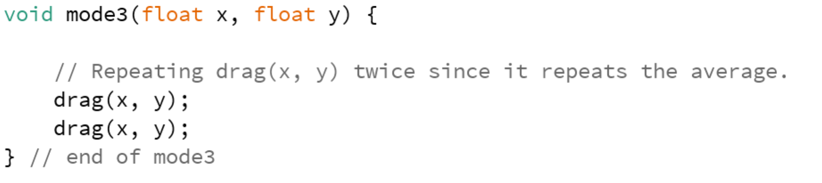

Extra credit:

A color changing feature. We keep all the color in an array, to keep changing the trail’s color. It looks way cooler than before.

There are two extra modes we have to create in this project just for extra fun and credit. In the mode 4, displaying the speed of circle movement by changing circle size. The mouse moves faster, the circle will become bigger, if the slower, then circles are smaller. In other words, the size of the circle is proportional to the distance between the current and the one before.

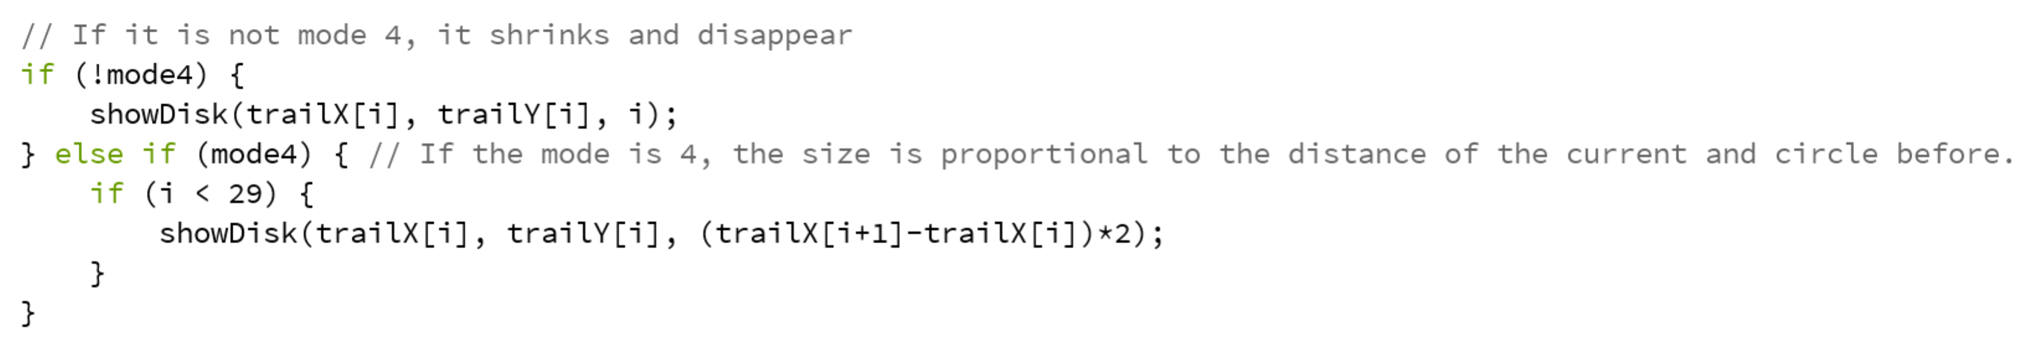

The mode 5, we call it High Mode! By using the random number to keep changing the position of points, making it shaking. And add a funny face to the circle. If you like it please thumb up!

